Q.No.01: Write a JavaScript program to print your name, date of birth and mobile number on browser.

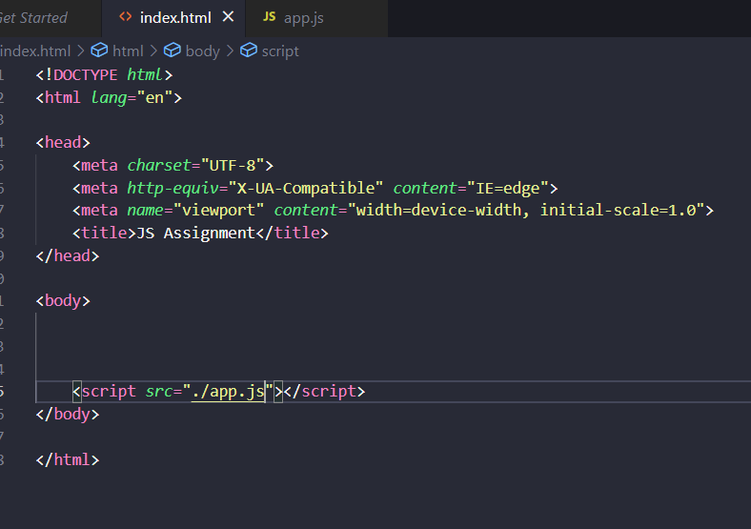

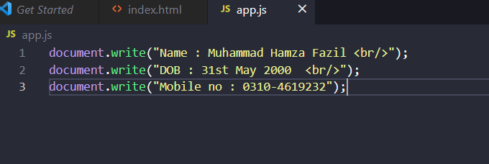

**Output:**

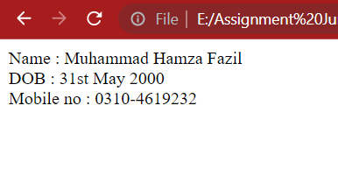

Q.No.02: Write a JavaScript program that accepts two numbers from the user and

Calculate the sum of the two numbers and show sum on browser.

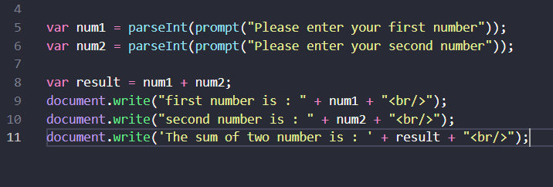

**Output:**

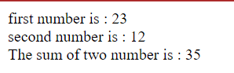

Q.No.03: Write a JavaScript program that accepts three numbers and find the maximum of three and show result on browser.

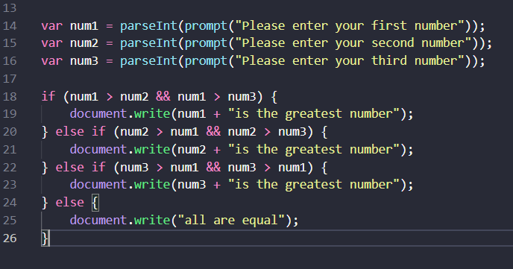

**Output:**

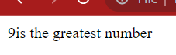

Q.No.04: Write a JavaScript program to check positive, negative or zero using simple if or if else and show result on browser.

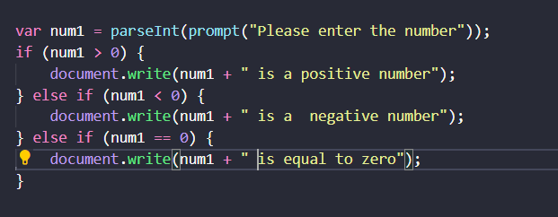

**Output:**

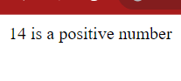

Q.No.05: Write a JavaScript program to check whether a number is even or odd using if else and show result on browser.

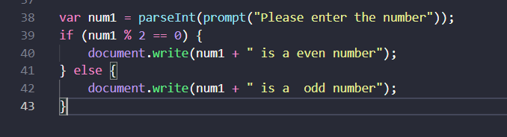

**Output:**

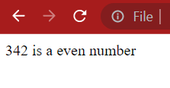

Q.No.06: Write a JavaScript program to check leap year using if else and show result on browser.

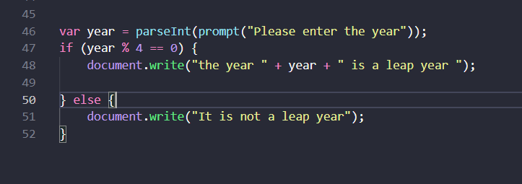

**Output:**

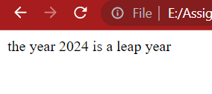

Q.No.07: Write a JavaScript program to check whether an alphabet is vowel or consonant using if else and show result on browser.

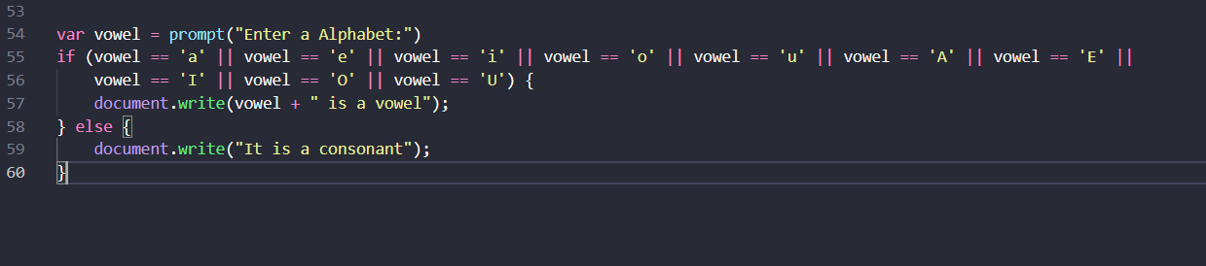

**Output:**

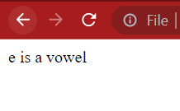

Q.No.08: Write a JavaScript program to input week number (1 -7) and print day of week name using switch case and show result on browser.

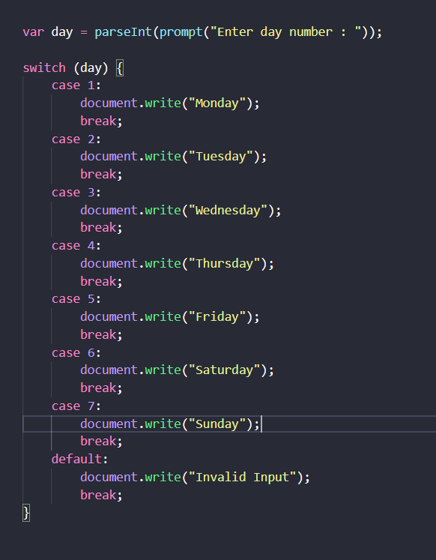

**Output:**

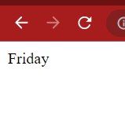

Q.No.09: Write a JavaScript program to input an alphabet and check whether it is vowel or consonant using switch case and show result on browser.

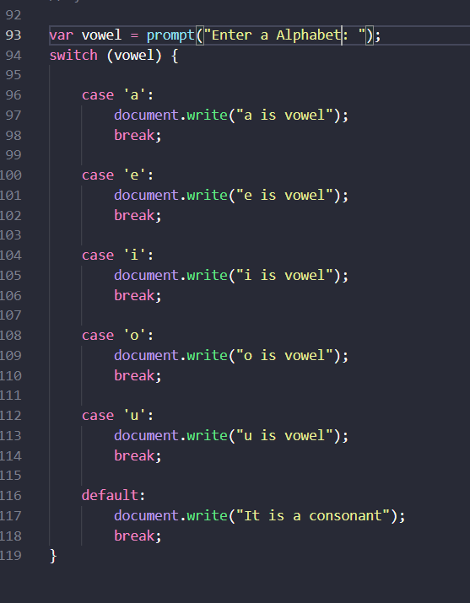

**Output:**

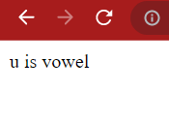

Q.No.10: Write a JavaScript program to create menu driven calculator that performs basic arithmetic operations (add, subtract, multiply and divide) using switch case and show result on browser.

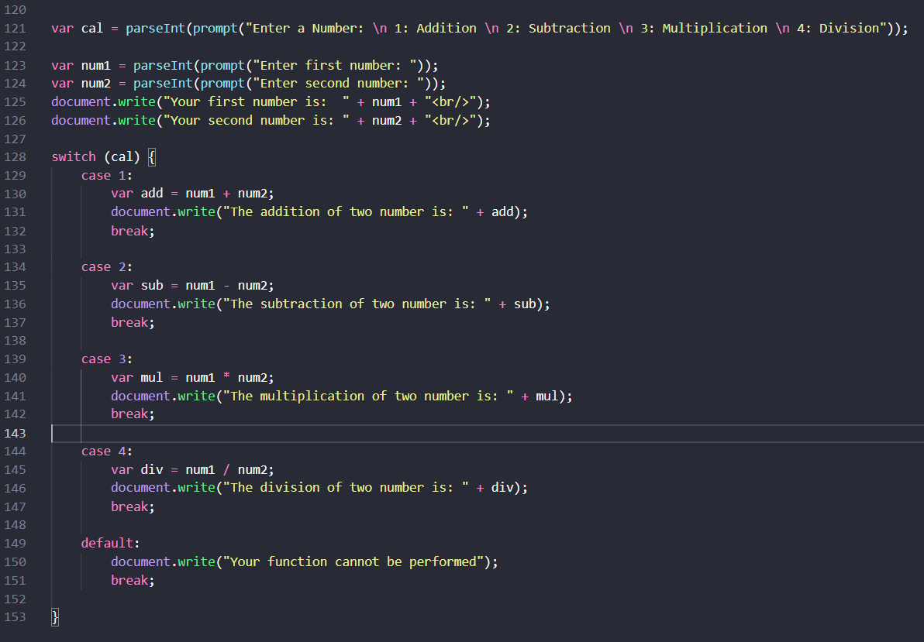

**Output:**

